Basic concept： 1

Characters 1

Bomb 2

Map 3

Game scene 3

UI： 3

Future Work 4

|  |  |  |
| --- | --- | --- |
| Modifying Date | Name | Content |
| 30.6.2017 | Duncan | Game Scene |
| 30.6.2017 | Duncan | Player Character Choice(Future work) |
| 30.6.2017 | Duncan | Change Damage Formula |
| 30.6.2017 | Jamie | Add sound and music requirement |
| 30.6.2017 | Jamie | Yellow = not finished yet |
| 02.07.2017 | Jamie | Change explosion time |

## Basic concept：

**Target audience:** Players who like party games

**Gamer type:** Casual gamers

**Target platform:** Windows

**Number of players:** 2~4

**Overview:** Players control characters to kick the bomb. After the bomb being instantiated for several seconds, it will explode. When it explodes, player who stays closest to the bomb will receive most damage. When there is only one player left, the game ends.

## Characters

Appearance: Capsules

**Movement:**

Use unity standard assets – characters – ThirdPersonCharacter – Prefabs - ThirdPersonController

**Skills:**

Shift: Rush x distance toward the direction player is facing

CD： 2秒

**Die:**

Player will disappear when he dies. Instantiate a skull at the place he died. The skull has not collider.

## Bomb

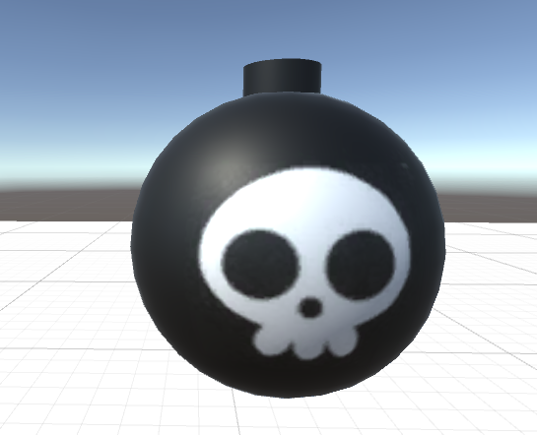

**Born position:**

Random. Be careful that it should not born at the players’ position.

**Explode time:**

8 seconds.

**Explode damage:**

~~For now, 1 damage for every players. (We will change the formula about its damage later.)~~

D is damage. d is distance between the boom and player.

**Animation:**

Black and red change from each other, the closer the bomb is going to explode, the color changes faster.

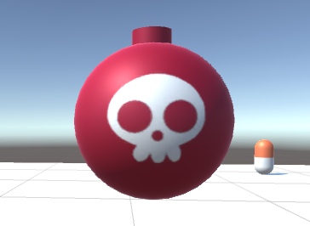

## Map

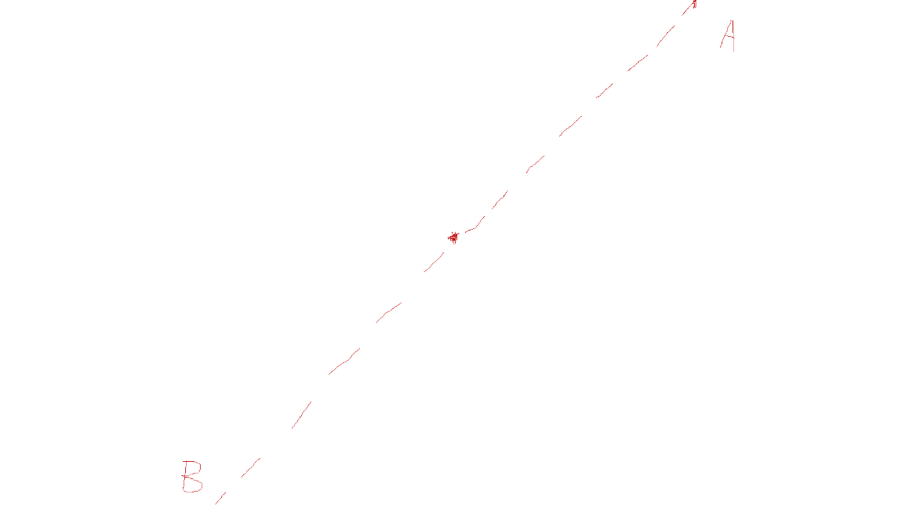

When the ball is going out of the screen from point A, it will appear at point B. Its speed, direction and explosion time will all remain the same. The only thing changes is its coordination.

When characters reach the border of the map, they cannot transform like the bomb, they will be stopped instead.

## Game scene

At the beginning of the game, four players stand in four corner. Position (X, 0, Z). Create a bomb in the center of the screen. Position (0, 0, 0)

Each time after the boom explodes, calculate the players' damage and players can move at this time. After 1 seconds create a new bomb in a random position.

## UI：

When the game is opened, there will be 3 options:

Start

Settings

Exit

**HP:**

HP should follow the players and stand at the right side of players.

70% - 100%: Green

30% - 69%: Orange

0% - 29%: Red

**Score Board**

Show the Score Board and two button “Replay” (Restart the game) and “Quit” (Quit game)

**Sound & music**

Required:

1. Bomb explosion(done)
2. Background music(done)
3. Player hit the ball
4. Game over music

## Future Work

**Boom create motion.**

Before the bomb appeared, there was a create animation

**Player Character Choice**

After click the “start play button”, there will be a scene for player to choice the character before the game real start.